#### ✅Be Aware of Child Developmental Stages and Milestones

💡**Overview**

It is important to be aware of different competencies and characteristics of children at different stages (2-9 years old). These characteristics of young children can shape parents’ expectations, goals, and activities with their children. It may be that the challenges and problems that parents face are rooted in expecting children to behave in ways that they are not yet developmentally ready for.

##### **Stages of Child Development**

**Toddler (2-3 years old)** 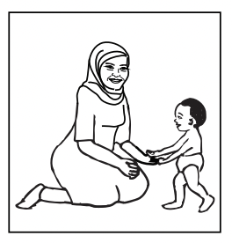

* Food, sleep, cleaning, comfort and safety.
* Strong attachment (bonding) with parent/ caregiver.
* Stimulation and attention.
* Becomes more curious; wants to explore and become more independent.
* Wants to learn how to do new things (e.g. dress and undress) and wants to make own decisions.
* Seeks praise and approval.
* Becomes more independent and continues to explore his or her surroundings.
* Starts speaking sentences and building vocabulary.
* Does not like to lose or take turns, but sharing can be taught.
* May express feelings in dramatic ways. Can begin to learn how to manage emotions.

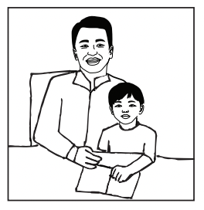

**Early Childhood (4-7 years old)**

* Food, sleep, cleaning, comfort and safety.
* Strong attachment (bonding) with parent/ caregiver.
* Stimulation and attention.
* Learns through actions and play.
* Develops relationships with other children. (Play is important and can teach social values.)
* Has questions; seeks answers.
* Finds it difficult to separate fantasy from reality.
* Expresses feelings in dramatic ways.
* May talk a lot; ask many questions. Answers can be short but should be honest. The child may ask again if it is not clear or if she or he wants more information.
* Does not like to lose, share or take turns, but losing and taking turns can be taught.

**Middle Childhood (8-9 years old)** 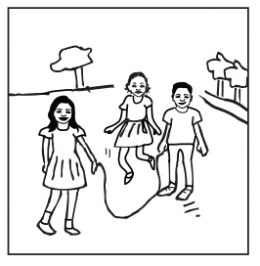

*Middle Childhood includes ages 8 to 12 years old.*

* Food, sleep, cleaning, comfort and safety.
* Strong attachment (bonding) with parent/ caregiver.
* Stimulation and attention.
* Interested in learning in school.
* Starts to want independence and trust.
* Wants to spend time with other children.
* May express interest in religious matters, spirituality.
* May answer back to adults to show that they “know”.
* Can be very self-conscious and sensitive. May be very active. (The child’s unique temperament emerges clearly at this stage.) But can learn to better manage anger and tolerate frustration.